LAB EXPERIMENT RECORD
Set 11 – Product Category Analysis
Department | AI&DS
Course Code / Course Name | DSA0602 / Data Handling and Visualization
Experiment | Data Visualization using R
Name | DEVAMADA HEMASREE
Register Number | 192524114
Date | 06 OCTOBER 2026
Day | FRIDAY

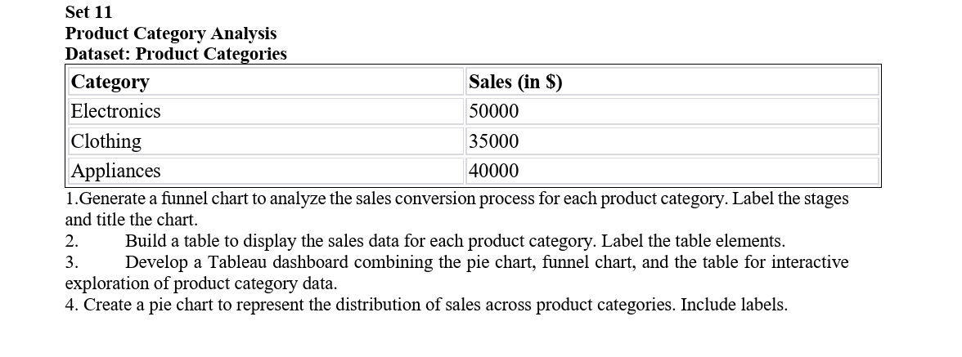

1. Funnel Chart
Aim:
To create a funnel chart to analyze the sales conversion process for each product category.
Code:
# Product Category data
category <- c("Electronics", "Clothing", "Appliances")
sales <- c(50000, 35000, 40000)

# Funnel chart using horizontal bars
barplot(sales,
names.arg = category,
horiz = TRUE,
main = "Sales Funnel by Product Category",
xlab = "Sales ($)",
col = "skyblue",
las = 1)

Output:
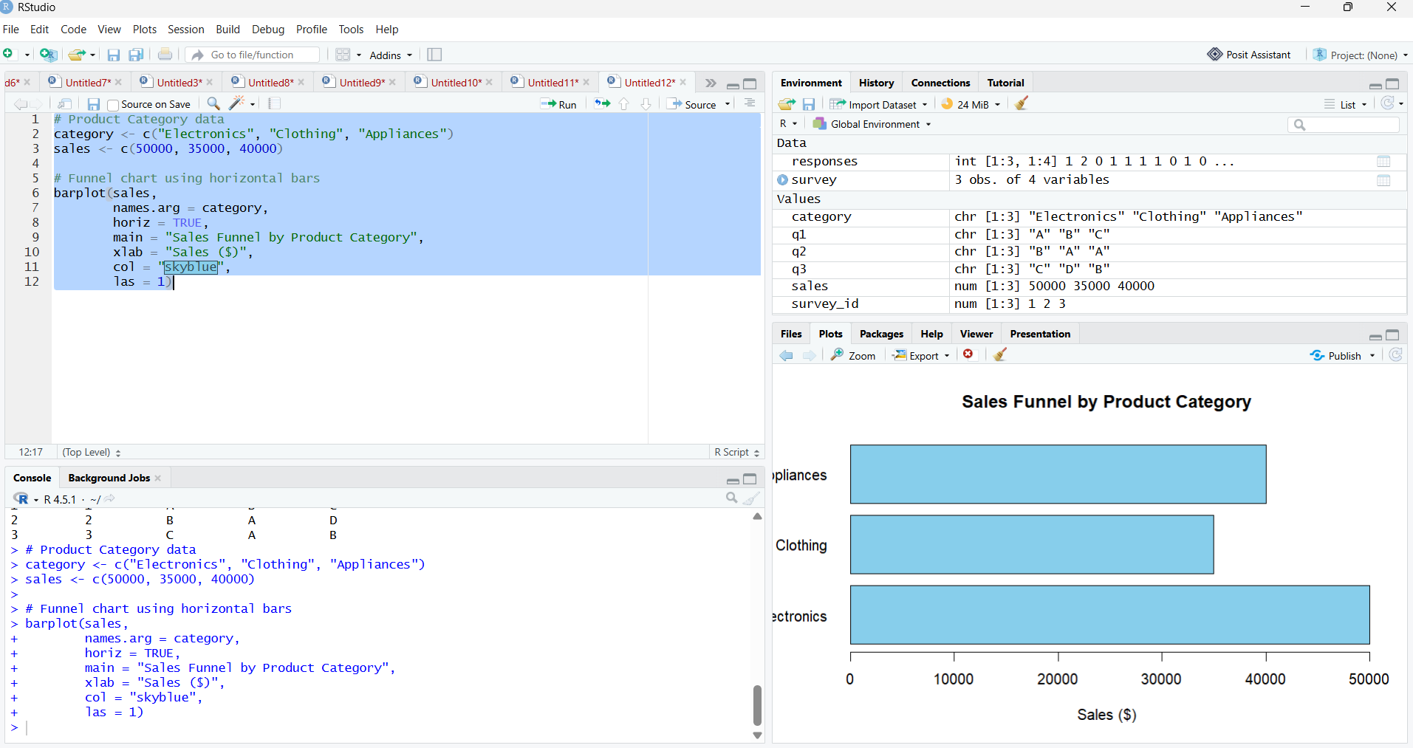

2. Table
Aim:
To create a table displaying the sales data for each product category.
Code:
# Product Category data
product <- data.frame(
Category = c("Electronics", "Clothing", "Appliances"),
Sales = c(50000, 35000, 40000)
)
# Display table
print(product)

Output:
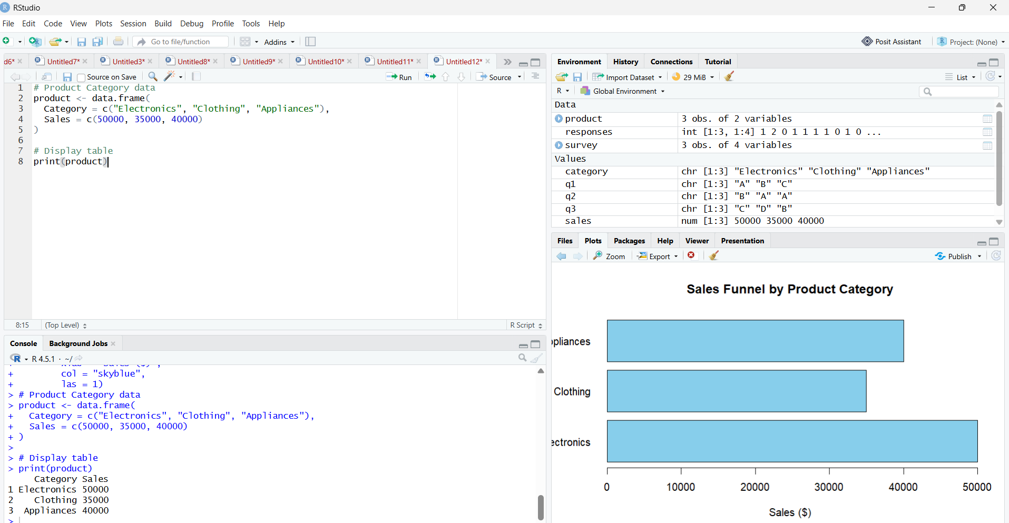

3. Tableau Dashboard
Aim:
To develop a Tableau dashboard combining the pie chart, funnel chart, and table for interactive exploration of product category data.
Output:

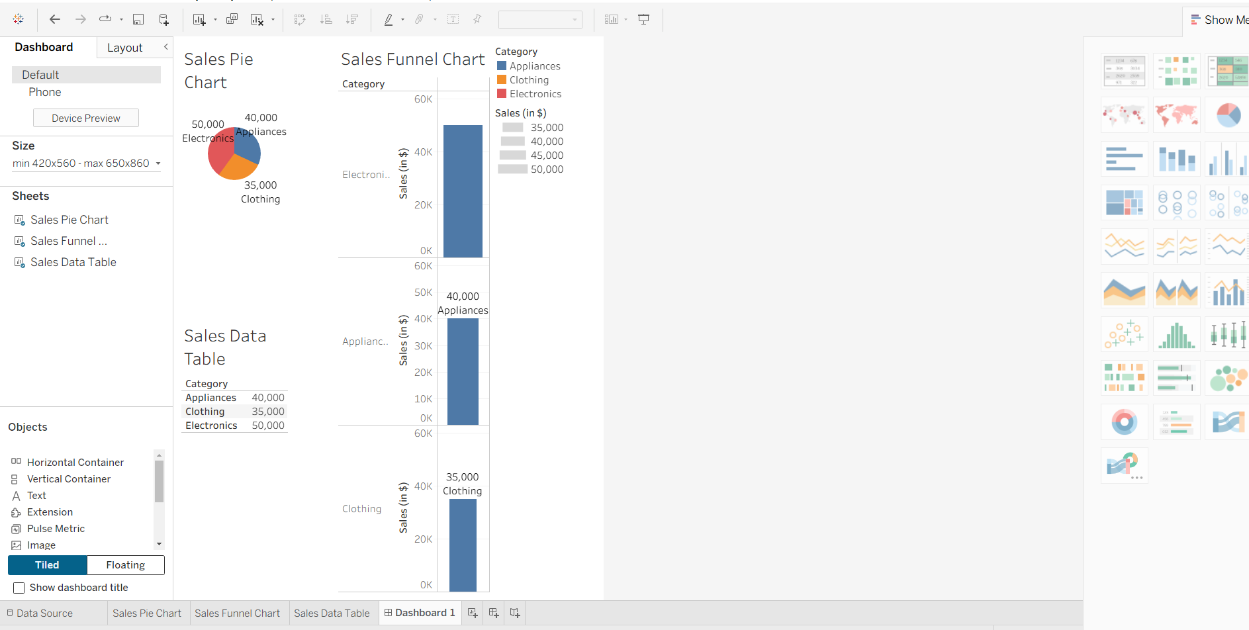

4. Pie Chart
Aim:
To create a pie chart representing the distribution of sales across product categories.
Code:
# Product Category data
category <- c("Electronics", "Clothing", "Appliances")
sales <- c(50000, 35000, 40000)

# Calculate percentages
percentage <- round(sales / sum(sales) * 100, 1)

# Labels
labels <- paste(category, percentage, "%")

# Pie chart
pie(sales,
labels = labels,
main = "Sales Distribution by Product Category")
Output:
